WORKSHEET 4
Student Name: Aradhya Sharma UID: 25MCC20042
Branch: MCA (Cloud Computing & Devops) Section/Group: 25MCC-101A
Semester: 2 Date of Performance: 03/02/2026
Subject Name: Technical Training 1 Subject Code: 25CAP-652

AIM: To understand and implement iterative control structures in PostgreSQL conceptually, including FOR loops, WHILE loops, and basic LOOP constructs, for repeated execution of database logic.
S/W Requirement:
To perform this experiment, the following software is required:
- Operating System
  - Windows 10 / 11, Linux, or macOS
- Database Management System (DBMS)
  - PostgreSQL (version 12 or higher)
- SQL Client / Interface
  - pgAdmin 4 (for PostgreSQL)
OR
  - Command Line Interface (psql)
OBJECTIVES:
- To understand why iteration is required in database programming
- To learn the purpose and behavior of FOR, WHILE, and LOOP constructs
- To understand how repeated data processing is handled in databases
- To relate loop concepts to real-world batch processing scenarios
- To strengthen conceptual knowledge of procedural SQL used in enterprise systems

Practical / Experiment Steps
• Iterative control structures in PL/pgSQL to understand repeated execution of logic.
• A simple FOR loop was executed to observe fixed-count iteration behavior.
• A FOR loop with a SELECT query was used to process records row by row.
• A WHILE loop was implemented to demonstrate condition-based iteration.
• A basic LOOP with EXIT WHEN was executed to control manual termination.
• Employee salary records were updated iteratively using a FOR loop.
• Conditional logic was applied inside loops using IF–ELSE statements.
• Outputs were verified using RAISE NOTICE statements.
Procedure for experiment
Example 1: FOR Loop – Simple Iteration
- The loop runs a fixed number of times
- Each iteration represents one execution cycle
- Useful for understanding basic loop behavior
Application: Counters, repeated tasks, batch execution
Query:
DO $$
BEGIN
FOR i IN 1..5 LOOP
RAISE NOTICE 'Iteration Number: %', i;
END LOOP;
END $$;

Output:
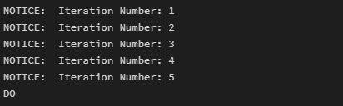
Example 2: FOR Loop with Query (Row-by-Row Processing)
- The loop processes database records one at a time
- Each iteration handles a single row
- Simulates cursor-based processing
Application: Employee reports, audits, data verification

For table – violation_schema
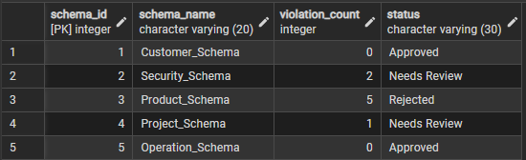
Query:
DO $$
DECLARE
rec RECORD;
BEGIN
FOR rec IN SELECT schema_name, violation_count FROM violation_schema LOOP
RAISE NOTICE 'Entity: %, Violations: %',
rec.schema_name, rec.violation_count;
END LOOP;
END $$;
Output:
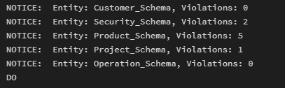
Example 3: WHILE Loop – Conditional Iteration
- The loop runs until a condition becomes false
- Execution depends entirely on the condition
- The condition is checked before every iteration
Application: Retry mechanisms, validation loops
Query:

DO $$
DECLARE
counter INT := 1;
BEGIN
WHILE counter <= 5 LOOP
RAISE NOTICE 'Counter Value: %', counter;
counter := counter + 1;
END LOOP;
END $$;
Output:
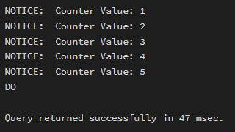
Example 4: LOOP with EXIT WHEN
- The loop does not stop automatically
- An explicit exit condition controls termination
- Gives flexibility in complex logic
Application: Workflow engines, complex decision cycles

Query:

DO $$
DECLARE
counter INT := 1;
BEGIN
LOOP
RAISE NOTICE 'Loop Count: %', counter;
counter := counter + 1;
EXIT WHEN counter > 5;
END LOOP;
END $$;
Output:
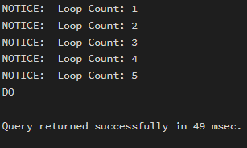
Example 5: Salary Increment Using FOR Loop
- Employee records are processed one by one
- Salary values are updated iteratively
- Represents real-world payroll processing
Application: Payroll systems, bulk updates
For table employee
Query:
DO $$
DECLARE
rec RECORD;
BEGIN
FOR rec IN SELECT id, salary FROM employee LOOP
UPDATE employee
SET salary = salary + 1000
WHERE id = rec.id;
END LOOP;
END $$;

Output:
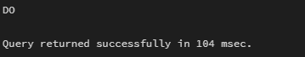
Example 6: Combining LOOP with IF Condition
- Loop processes each record
- Conditional logic classifies data during iteration
- Demonstrates decision-making inside loops
Application: Employee grading, alerts, categorization logic
For table studentgrades
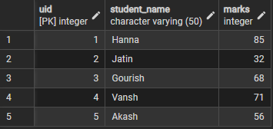
Query:
DO $$
DECLARE
rec RECORD;
BEGIN
FOR rec IN SELECT student_name, marks FROM studentgrades LOOP
IF rec.marks >= 75 THEN
RAISE NOTICE '% : Distinction', rec.student_name;
ELSE
RAISE NOTICE '% : Needs Improvement', rec.student_name;
END IF;
END LOOP;
END $$;

Output:
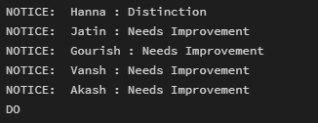

Learning Outcomes
- Understand the importance of iteration in database programming and procedural SQL.
- Differentiate between FOR, WHILE, and LOOP constructs in PostgreSQL.
- Implement fixed and conditional iterations using PL/pgSQL blocks.
- Perform row-by-row processing of database records using loop structures.
- Apply conditional logic (IF–ELSE) within loops for data classification.
- Relate loop constructs to real-world applications such as payroll processing, reporting, and batch updates.

